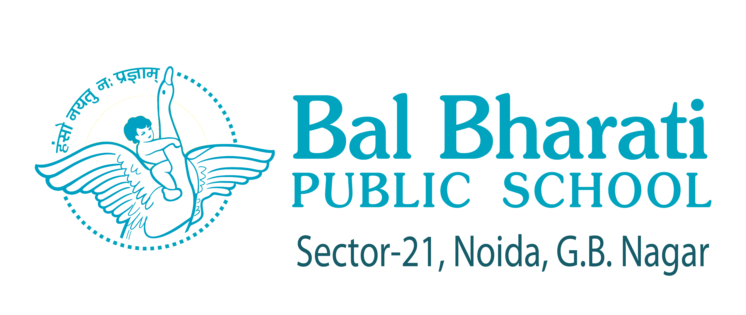

ION No.13/2025-26 Date : 01 May, 2025

INVESTITURE CEREMONY

“The greatest leader is not necessarily the one who does the greatest things. He is the one who gets the people to do the greatest things

The 20th INVESTITURE CEREMONY will be held on 08 May, 2025 (Thursday) in the School Auditorium at 10.30 a.m.

Given below is the list of various duties with names of In charges indicated against each area of responsibility.

Duties Tr-In-Charge

- Convenor(s)  - List of selected candidates with SOPs to be handed over to committees  - List of Students to be submitted after reviewing SOPs  - Leadership Camp at DME 02 May 2025  - List of Student to be submitted after Interview | :  :  :  :  : | Ms Ruby S, Ms Vibha Jain, Ms V.Oberoi &  Ms Ruchika K, Ms Anita Verma (Under the supervision of VPL & HM (Sr) & HM (Pr)  Class XII- Ms Vibha Jain  Class XI-Ms Vidhi Oberoi  Class X- Ms Neerja B  Class XII- VPL, Ms Swati C  Class X & XI-HM Sr, Ms Neerja B  Ms Ruby S, Ms Vibha J, Ms Vidhi Oberoi  Class XII- VPL, Ms Swati C  Class X & XI-HM Sr, Ms Neerja B

- Budget for Investiture Ceremony  - Procurement and issue of Badges & Sashes | :  : | Ms. Ruby Singh/ Ms. Vidhi Oberoi and  Ms. Ruchika Khanna.  Ms Ruby Singh, Ms Abha B, Anita V
- Cultural Programme (Duration : 7-8 Min)  - Costumes & Makeup | :  : | Mr P Pallavi & Ms Sumana, Ms Nisha  Mr Swapan M, Ms Kavita Pandey & Ms Nisha Ray
- Emcee Mentor | : | Ms Rachna Sondhi, Ms Poonam S & Ms Sona
- Stage Decoration | : | Mr Faiz, Mr Yuvraj, Mr Niladri S Das
- Sound System | : | Mr Varun & Mr P Pallavi
- Stage Lights | : | Mr Varun & Mr Swapan
- Preparation of Certificates | : | Ms Abha B, Ms Deepti M, Ms Bhumika &  Ms Charu
- PPT Presentation  - Setting of the screen for PPT | :  : | Ms Meetu (XII), Ms Meenakshi (XI),  Ms Sonam (X),  Ms Garima Priya (Primary)  Mr. Raj Kumar and Mr. Narender
- Photography | : | Mr Yuvraj & Mr Faiz A
- Videography | : | Mr Niladri S Das
- Tea/Miscellaneous Arrangements | : | Ms Neha Gupta, Ms Ankita B & Ms Maya
- Report Writing /Press Release /  Uploading of pictures video with a write up on conclusion of the programme on SCHOOL WEBSITE | : | Ms Rachna Sondhi Ms Nishi Sourabh (Press Release by 12 May, 25)  Mr Yograj and Mr. Niladri S Das  (The same should be uploaded latest by 13 May, 2025).
- Designing of post event magazine – ‘Fountainhead’ | : | Ms Sonam M & Mr Niladri S Das
- Setting up of AUDI /Seating Arrangement | : | Mr Umesh Verma, Mr Sanjay Dua &  Ms Rani Negi, Mr Vardhan
- Invitation Teaser  - E-Card Design | :  : | Ms Alka Rai/ Mr. Yuvraj  Mr. Faiz A
- Letter to Parents  (To be dispatched to the parents latest by 01 May, 25) | : | Ms. Vibha Jain, Ms Subha R , Ms Mukul S &  Ms Diksha
- Arrangement of House Flags | : | Respective House Wardens /Mr D Bist /  Mr Vardhan / Ms Rani Negi
- Rehearsals with Drum | : | Mr D Bist, Ms Rani N
- Aesthetics / Placing of Green Pots | : | Ms Indula M & Ms Vidhi O
- Operation of Genset | : | A.O./School Electrician / Mr Jagatpal
- Student Discipline  - Back Stage Discipline  - Discipline in the Gallery  - Discipline in the Auditorium | :  :  :  : | Concerned Class Reps. / Mr Vardhan S  Ms. Yasha and Ms. Komal  Mr. Ankit S and Mr Nilesh Roy  Ms Vibha Jain / Ms. Dipti T/Ms. Smriti

PROGRAMME

- Floral Felicitation | : | President Designate  Head Girl Designate (Pr) & (Sr) Head Boy Designate (Pr) & (Sr) Under the supervision of Ms Neerja B
- Welcome Address | : | Principal
- Address by the President Designate | : | Mentor - Ms Kamna. J (Students Council)
- ‘Nayi Subah’ – A Motivational Song celebrating each new dayas a fresh beginning filled with hope and opportunities | : | Mr P Pallavi and Ms. Sumona Sen
- Felicitation of Primary Student Council | : | Ms Ruchika Khanna, Ms Anita Verma, Mr Dipti Singh
- Address by the Chief Guest | : | Dr. Jitendra Nagpal, a distinguished psychiatrist and youth wellness expert, committed to fostering mental health, life skills and holistic development in children and adolescents.
- ‘Tarang’ – A Kathak Presentation which beautifully depicts the sweet banter between Radha and Krishna, highlighting Radha’s playful jealousy towards Krishna’s beloved flute. Musical Presentation | : | Ms Kavita Pandey
- Felicitation of the Sr School Student Council | : | Ms Ruby S, Ms Vibha J, Ms Abha B, Ms Vidhi Oberoi, Mr Dipti Singh
- Oath | : | Head Boy & Head Girl, Student Council  Mentor : Ms Neerja b, Ms Rani N (On the ground)
- Vote of Thanks | : | Vice President, Student Council Mentor:  Ms Rachna Sondhi
- National Anthem | : | Mr P Pallavi and Music Department

Winding up of Auditorium after the event will be responsibility of the Convenor

Asha Prabhakar
(Principal)


Distribution
VPL, HMs, A.O & All Staff (via e-mail)
Website, A Razdan (File)

