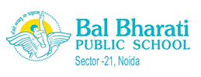

FORTNIGHTLY REPORT ON GOOGLE CLASSROOM
CLASS : XI-A
DATE FROM 26th Oct. to 27th Nov., 2020
Students of Class XI-A attended online classes through Hangouts Meet app as per the Time Table
Additional Links Video/PPT Provided To Supplement The Teaching circulated and were provided the following worksheets, videos and online academic materials to enhance the learning outcome.

Subject  &  Subject Teacher | Topics Covered | Link / Assignments Uploaded On Google Classrooms | Assessment Taken(Yes/No)  (Quiz/Graded Test/Viva/Google Form/Group Discussion) | Mode Of Teaching &  Additional Links Video/PPT Provided To Supplement The Teaching
English  Rumpa B | Literature - Snapshots  Lesson - Birth ( ref to works by Dr Kotnis and films based on him ) .  Ref to A.J.Cronin's Medical journal Citadel .  Poem Childhood by Markus Natten .  Critical appreciation with ref to Poetic Diction and Rhyme Schemes used by poet .  Speaking skills/ interactions based on motivational speech by Gour Gopal Das . | Unit 3 papers uploaded in Google Classroom .  Ref questions and answers / RTCs of poems uploaded .  Note Making and summary notes with exercises uploaded in Google Classroom . | Graded Round 3 papers  Group Discussions and Note Making done in class . | Videos and links on inspirational and discursive speeches by Gour Gopal Das and films on Dr Kotnis highlighting medical ethics .
Physics  Rani Vaid | Chapter - Mechanical properties of Solids  Chapter - Fluids : Viscosity | ---- | Assessment was taken using discussion of Numericals and conceptual questions. | Using presentations, discussion method and various real life examples , concepts were explained .
CHEMISTRY  Ms. Vibha Jain | Chemical Equilibrium physical and chemical processes,characteristics of equilibrium constant, relation in KP and KC, application of equilibrium constant, Ionic Equilibrium, processes acid, base and salt- different concepts degree of dissociation of weak electrolyte buffer solution common ion effect solubility product | https://youtu.be/UjGvACOBcEs  https://youtu.be/bRoKmT2bLA0 | All intext questions were discussed and questions from back exercise were also discussed  UT-3 will be held on 1 December 2020. | Sharing of notes along with PPT , and sharing the soft copy of assignment on laptop.
Artificial  Intelligence  Sheetal Sharma | Green Skills  ICT Skills  Exploring Data | Numericals on Exploring data | https://classroom.google.com/c/NjkzNjI2MTAyMTFa/m/MjA3NjM2MjUzNDc1/details | https://classroom.google.com/c/NjkzNjI2MTAyMTFa/m/MjA3NjQyMzUzNjUw/details
Computer Science  Ms. Meetu Tripathi | Functions in Python  Built in Functions  User Defined Functions  Lists in Python  Built in functions for list operations | Assignment on Functions and Lists | Online Round 3 assessment was taken up on 24th November  Programs based on the topic done in class | Notes and NCERT Book
MATHEMATICS  ANJALI S | SEQUENCE AND SERIES  Geometric Progression  General term, Sum of n terms  STRAIGHT LINES  Slope of a line  Condition of parallel and perpendicular lines  Angles between two given lines using slopes  Equations of Straight lines in specific form  POINT SLOPE FORM  TWO POINT FORM  SLOPE INTERCEPT FORM  INTERCEPT FORM  NORMAL FORM  Conversion of the general form into one of the above forms | Assignment related to the topic uploaded on Google Classroom | Online Round 3 assessment was taken up on 17th November  Class assessment in the form of group discussions and presentation of the work | Mode of teaching is explanatory with examples from real life  Students were given explanation of Vedic Maths Sutra YAVADUNAM SUTRA  Practical activities from the topic Sequence and series undertaken

New Initiatives
v On 26th November, 2020 at 10:30am, the school took an initiative to organise a counselling session for the students of classes 10 and 12 who are to appear for the Board Exams. India's TOP Career Counsellor - Mr Jitin Chawla addressed the students on the topic-Target 2021 Boards: Tips on how to score better marks in boards.
v On October 31st, 2020 a webinar on How to Manage Stress and Become Functional was held. Ms Aditi Gaur (PGT-Psychology) and School Councillor, BBPS, Noida, was one of the keynote speakers of the prestigious event. The other speakers of the same event were Dr. Neerja Pandey, Asst. Prof. AIBAS, Amity University, Lucknow, Gagandeep Kaur, Double Gold Medallist, Clinical Psychologist, Director UPS.
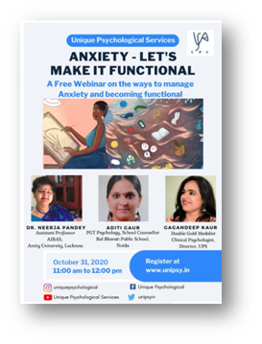

Awards and Achievements
Winning laurels has always been a part of the Bal Bharati culture. In a spate of Inter School competitions held during this time span, our students outshone the rest by a clear margin in several events that we were invited for in the past one month.

Ø Aaditya Kartikeya was selected to go through an extensive AI learning journey and virtual mentorship camps in July 2020 offered by AI for Youth Symposium Team.
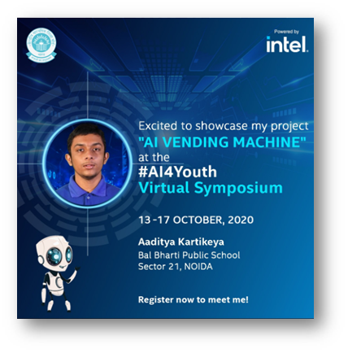
Ø A live webinar on ‘Autonomous Vehicles and Future Technology’ by Mr Soumitra Dey, Mentor of Change, AIM was conducted for the students of Classes IX – XII on 25 Sep, 2020. An online quiz was also conducted after the session. Divyanshu Salwan (XI), Tanya Kudaisya (XI), Aachman Ghildyal (XI) were the winners of the quiz and were awarded with Internet of things (IOT) development Arduino kits.
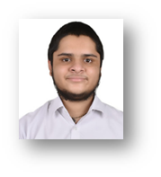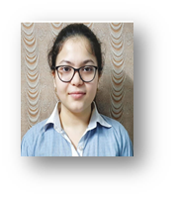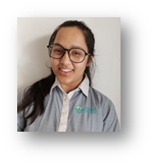
Ø Dr. Satya Paul Memorial Inter School ENGLISH DEBATE (2020) was held at APEEJAY SCHOOL, NOIDA on 28th October. Ananya Nair (XII D) was adjudged the Second Best Speaker (Individual Category) amongst 90 speakers.
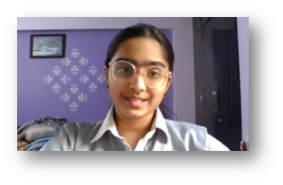
Ø Several citations of honour were received by children who participated in the online mental health initiative by Expressions India held under the aegis of Institute of Mental Health and Life Skills, New Delhi from 4-10 October 2020.
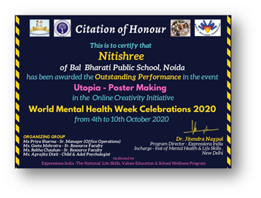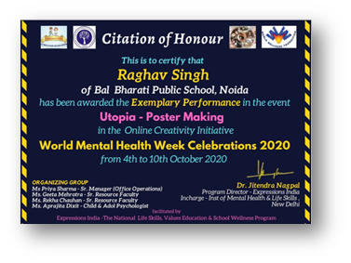
Ø Sarwagya Prasad – XII secured the I position in Sr. Programming at Sillico Battles – Alchon Public School, Delhi.
Ø BBPS, Rohini hosted a quiz contest to observe Mole Day on 23rd October, 2020. Sarwagya Prasad (XII-A) stood first in the prestigious event ‘Quizzard- a Chem Quest’.
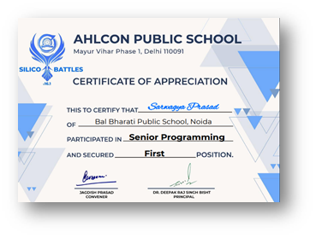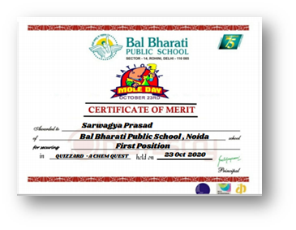
Ø Srishti Anand secured the III position at the event, CODE - Apeejay School , Noida
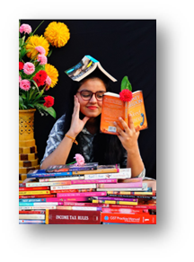
Ø Shambhavi Chaudhary (12B) bagged the III position in the event, the Modern Victorian, Zenith 2020- an online competition held at BBPS Pitampura
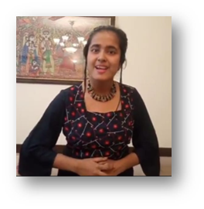
Ø With a lot of pleasure and pride we would like to share that the outgoing batch of class XII from different streams have been accepted by prestigious colleges all over the country. Several elite colleges of Delhi University, Christ University (Bangalore), Indian Institute of Technology ( Patna & Bhopal), SPA (Bhopal), Medical Colleges like KGMC to name a few
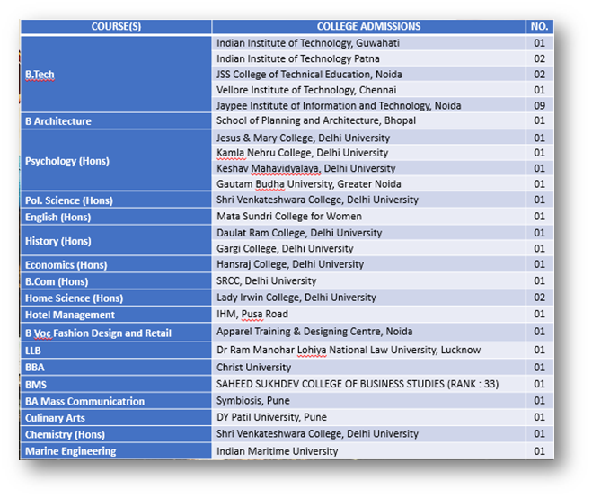
Celebrations
Ø Constitution Day was celebrated by the History and Political Science Dept. of the school on 26th November by hosting a webinar for the students of classes XID & XIID. The teacher in charge for the same was Ms Shally Walia (PGT- Pol Sc. & History). An enlightening discussion on the fundamental duties of a citizen of India was held to bring home the rights and duties of the citizens belonging to this proud nation.
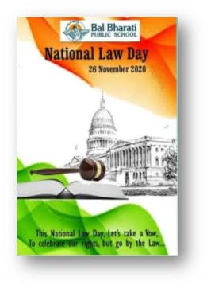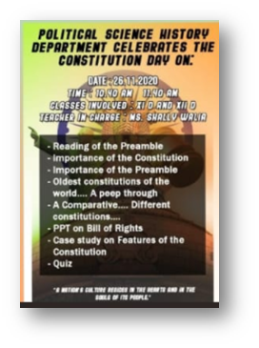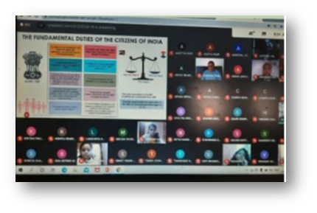

Half Yearly Exams
Ø Half Yearly exams for classes IX-XII were held from 7 to 21 October, 2020 via the Online platform. PTM for the same was held from 9-11Nov. 2020
Important CBSE circular
· Merit Scholarship Schemes
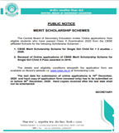
· SOP Guidelines for reopening of schools after Covid-19 Lockdown.A




